THE OHIO STATE UNIVERSITY
May 12, 2021
Associate Professor Maria Miriti
Chair, Arts and Sciences Curriculum Committee
College of Arts and Sciences
Department of English
421 Denney Hall
164 Annie and John Glenn Ave
Columbus. OH 43210-1370
614-292-6065 Phone
englishgosu.edu http://english.osu.edu

Re: Approval of Proposal to make credit hour changes to the Art BFA
Dear Maria,
At its meeting on Monday, April 26, 2021, the ASCC Arts & Humanities Panel 2 unanimously approved an Art Department proposal to make credit hour changes to the Art BFA. Specifically, the proposal calls for a reduction in the number credit hours required within one of the seven areas of specialization, from 27 to 18, and a corresponding expansion of the number of credit hours in elective studio courses, from 12 to 21. The current requirement that students complete 77 credit hours in the major remains unchanged.
These changes come as part of the Art Department’s rethinking of its undergraduate curriculum in response to recommendations made in reviews of the department conducted by peer institutions and the National Association of Schools of Art and Design. One of the concerns that emerged from these reviews was that the department requires too many credit hours in a student’s chosen area of specialization, and too little opportunity to do elective coursework in other areas. The current proposal addresses these concerns.
ASCC Panel 2 found the proposed changes sensible and timely, and likely to encourage flexibility and interdisciplinarity within the Art BFA major. It therefore now advances the proposal to the Arts and Sciences Curriculum Committee with a motion to approve.
Sincerely,

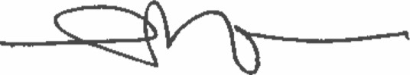
Luke Wilson
Associate Professor
Department of English
Chair, ASCC Arts & Humanities Panel 2

